Chapter 6, Problem 72.

At t = 1.5 ms, calculate v_{o} due to the cascaded integrators in Fig. 6.89. Assume that the integrators are reset to 0 V at t = 0.

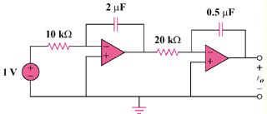

Figure 6.89
For Prob. 6.72.

